Project Design Phase Problem – Solution Fit Template

Student Name | Navya Sri Tangellamudi
Project Name | Intergalactic Space Travel Request System (ISTR)
Maximum Marks | 2 Marks

Problem – Solution Fit Template:
For ISTR, Problem-Solution Fit means confirming that the mission-approval problems faced by Requesters, Managers, Finance Officers, and Mission Control are real, and that the ISTR system genuinely solves them. It helps the team identify behavioral patterns among these stakeholders and recognize what would work and why.

Purpose:
- Solve mission-approval complexity in a way that fits how requesters, managers, and mission control actually work.
- Succeed faster and increase adoption of ISTR by tapping into existing channels of behavior (portal, email, briefings).
- Sharpen ISTR's rollout communication and training with the right triggers and messaging.
- Increase touch-points with the system by finding the right problem-behavior fit and building trust through faster, auditable approvals.
- Understand the existing (manual) approval situation in order to improve it for mission stakeholders.

Customer Journey Flow:
The flow below traces the journey from what triggers a mission request, through the job-to-be-done and today's manual behaviour, to the channels involved, ISTR's automated solution, and the resulting outcome.
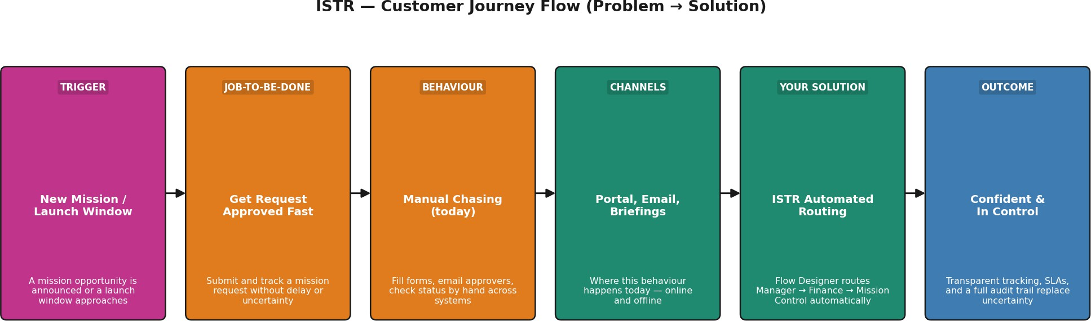

Template:

Define CS, fit into CC | 1. CUSTOMER SEGMENT(S)  Mission stakeholders within an interplanetary space agency: Requesters (explorers/researchers), Managers, Finance Officers, Mission Control officers, and System Administrators. | 6. CUSTOMER CONSTRAINTS  Strict regulatory/compliance requirements across agencies, limited connectivity from remote research posts, per-mission budget caps, tight launch windows, varying role-based access levels. | 5. AVAILABLE SOLUTIONS  Manual email/spreadsheet requests, paper-based approval chains, generic ticketing tools without role-based routing, ad-hoc phone approvals. Pros: familiar, no new tooling. Cons: slow, error-prone, no audit trail, no SLA enforcement. | Explore AS, differentiate
Focus on J&P, understand RC | 2. JOBS-TO-BE-DONE / PROBLEMS  Submit and get mission travel requests approved quickly; review/approve budgets and risk without delay; maintain visibility into request status; ensure only fully-approved missions are launched. | 9. PROBLEM ROOT CAUSE  No unified system routes requests by role or risk level; manual processes can't scale with growing mission volume or with mixed inter-agency and regulatory approval requirements. | 7. BEHAVIOUR  Directly related: fill out request forms, chase approvers via email/chat, manually check status. Indirectly associated: attend mission briefings, consult Mission Control advisories. | Focus on J&P, tap into BE
Identify strong TR & EM | 3. TRIGGERS  A new mission opportunity is announced; an upcoming launch window approaches; a requester's deadline nears; a Manager receives an SLA escalation reminder. | 10. YOUR SOLUTION  ISTR (Intergalactic Space Travel Request System): a ServiceNow app with a custom request table, Flow Designer approval routing (Manager -> Finance -> Mission Control for High/Critical risk), role-based access control, SLAs with escalations, real-time notifications, full audit trail, and an Admin-only Launch action. | - CHANNELS of BEHAVIOUR  - Online: ServiceNow Service Portal, email notifications, role-based dashboards. 8.2 Offline: in-person mission briefings, printed manifest reviews, control-room status boards. | Extract online & offline CH of BE
 | 4. EMOTIONS: BEFORE / AFTER  Before: uncertain, overwhelmed by manual paperwork, anxious about delays or errors. After: confident, in control, reassured by transparent tracking, automated routing, and a full audit trail. | PURPOSE / VISION  To make interplanetary mission approvals fast, transparent, auditable, and scalable as space-travel operations grow.

References:

- https://www.ideahackers.network/problem-solution-fit-canvas/
- https://medium.com/@epicantus/problem-solution-fit-canvas-aa3dd59cb4fe

Project Design Phase-II Problem-Solution Fit Canvas — ISTR

Student Name | R.Nagarjuna Raju
Project Name | Intergalactic Space Travel Request System (ISTR)

1. CUSTOMER SEGMENT(S)  Mission stakeholders within an interplanetary space agency: Requesters (explorers/researchers), Managers, Finance Officers, Mission Control officers, and System Administrators. | 6. CUSTOMER CONSTRAINTS  Strict regulatory/compliance requirements across agencies, limited connectivity from remote research posts, per-mission budget caps, tight launch windows, varying role-based access levels. | 5. AVAILABLE SOLUTIONS  Manual email/spreadsheet requests, paper-based approval chains, generic ticketing tools without role-based routing, ad-hoc phone approvals.  Pros: familiar, no new tooling. Cons: slow, error-prone, no audit trail, no SLA enforcement.
2. JOBS-TO-BE-DONE / PROBLEMS  Submit and get mission travel requests approved quickly; review/approve budgets and risk without delay; maintain visibility into request status; ensure only fully-approved missions are launched. | 9. PROBLEM ROOT CAUSE  No unified system routes requests by role or risk level; manual processes can't scale with growing mission volume or with mixed inter-agency and regulatory approval requirements. | 7. BEHAVIOUR  Directly related: fill out request forms, chase approvers via email/chat, manually check status. Indirectly associated: attend mission briefings, consult Mission Control advisories.
3. TRIGGERS  A new mission opportunity is announced; an upcoming launch window approaches; a requester's deadline nears; a Manager receives an SLA escalation reminder. | 10. YOUR SOLUTION  ISTR (Intergalactic Space Travel Request System): a ServiceNow app with a custom request table, Flow Designer approval routing (Manager -  > Finance -> Mission Control for High/Critical risk), role-based access control, SLAs with escalations, real-time notifications, full audit trail, and an Admin-only Launch action. | - CHANNELS of BEHAVIOUR  - Online: ServiceNow Service Portal, email notifications, role-based dashboards. 8.2 Offline: in-person mission briefings, printed manifest reviews, control-room status boards.
4. EMOTIONS: BEFORE / AFTER  Before: uncertain, overwhelmed by manual paperwork, anxious about delays or errors. After: confident, in control, reassured by transparent tracking, automated routing, and a full audit trail. | PURPOSE / VISION  To make interplanetary mission approvals fast, transparent, auditable, and scalable as space-travel operations grow.

